**Conjoint Analysis on Smart Glasses**

**Introduction**

The integration of technology into consumer products has revolutionized the accessories market, notably through the advent of Smart Glasses. These products offer a blend of style, functionality, and innovative technology like Augmented Reality (AR). This report presents the findings from a conjoint analysis conducted to determine the optimal attributes for Smart Glasses that align with consumer preferences.

**Rationale for selection of the attributes and levels**

1. **Price:**

**Rationale:** Our analysis recognized price as a pivotal factor for consumers, with varying sensitivities highlighting the balance between affordability and willingness to invest in new technology. Price points were derived from consumer feedback emphasizing the trade-off between cost and advanced features.

**Levels:**

Level 1: $250, accommodating budget-conscious consumers looking for basic AR

Level 2: functionality; $300, a mid-range price aligning with average consumer expectations.

Level 3: $500, catering to those seeking premium features in AR eyewear.

1. **Camera:**

**Rationale**: Camera quality surfaced as a crucial feature for AR applications. High megapixel cameras are associated with superior AR visuals, enhancing the overall user experience.

**Levels**:

Level 1: 8 Mp, for basic camera

Level 2: 12 Mp, for a high-resolution camera experience.

1. **Interaction Method:**

**Rationale:** The mode of interaction with Smart Glasses affects usability and consumer satisfaction. Preferences indicated a divide between gesture control for seamless operation and voice control for hands-free interaction.

**Levels:**

Level 1: Gesture, for intuitive and natural user interaction

Level 2: Voice, for convenience and accessibility in controlling various functions.

1. **Bone Conduction Audio:**

**Rationale**: Consumers expressed a strong interest in innovative audio solutions that do not obstruct environmental awareness, thus enriching the AR experience without isolating the user.

**Levels:**Level 1: Yes, integrating bone conduction for a more immersive and safer audio experience.  
Level 2: No, for consumers who may prefer traditional audio methods or prioritize other features.

1. **AI Assistant:**

**Rationale:** The desire for smart, responsive technology was evident, with consumers valuing the utility of AI for enhancing interactivity and providing hands-free controls within the AR ecosystem.

**Levels:**

Level 1: Yes, offering advanced interactivity and functionality.

Level 2: No, for a focus on basic AR features without the addition of AI complexity.

1. **360 Degrees View:**

**Rationale:** A panoramic view was sought after for a fully immersive AR experience, but its importance varied among users, with some preferring simplicity and direct interaction.

**Levels:**

Level 1: Yes, for an expansive and immersive AR experience  
Level 2: No, keeping the experience straightforward and possibly reducing the cost and complexity.

1. **AR Map Navigation:**

**Rationale**: Navigation assistance was recognized as a desirable feature, but its priority differed among consumers, with some considering it non-essential compared to other AR features.

**Levels**:

Level 1:Yes, for integrated real-time navigational assistance.

Level 2: No, where navigation is not a central feature of the AR experience.

1. **Polarisation:**

**Rationale**: Polarisation emerged as a feature that combines traditional eyewear benefits with new technology, suggesting that consumers do not want to compromise on the basic expectations of sunglasses.

**Levels**:

Level 1: Yes, offering glare reduction and visual comfort.  
Level 2: No, focusing purely on the technological aspects of AR.

The attributes and levels were chosen to create a product offering that reflects the diverse needs and preferences identified in the market research.

Based on the in-depth interviews and group discussions conducted with members of the target group, we were able to glean insights into the consumer priorities and preferences regarding Smart glasses. The preliminary research aimed to identify the most valued attributes of Smart glasses and to understand the reasons behind these preferences. These insights were essential for isolating relevant factors and their corresponding levels for the conjoint analysis project.  
**Sidra’s Target Group Interviews:**

1. Tim Earnest, Age : 26, Occupation : Project Management - PM, Ethnicity : White, Male
2. Huzaifa Naeem, 39, Director Tech , Brown, Male
3. Lola, 23, Student, Black, Female

**Satvik’s Target Group Interviews:**

1. Abhiram Chada, 24, Graduate Student, brown, Male, Tampa
2. Shravani Mysuru, 29, Software Developer, Brown, Female, Charlotte
3. Amolika Godse, 26, Graduate Student, Brown, Female, Tampa

**Kerry’s Target Group Interviews:**

1. Harry Wood, 30, Financial Analyst, White, Male
2. Lorraine King, 28, Teacher, White, Male
3. Kevin Bundi, 38, Engineer, Black, Male

**Profile details and rationale for choosing Conjoint Analysis.**

Total number of profiles in the original design: **15**

Number of ranked profiles: **10**

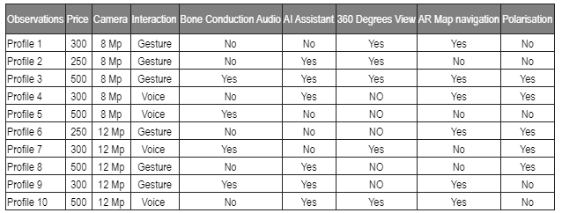

**Target group - Demographics.**

**Gender**

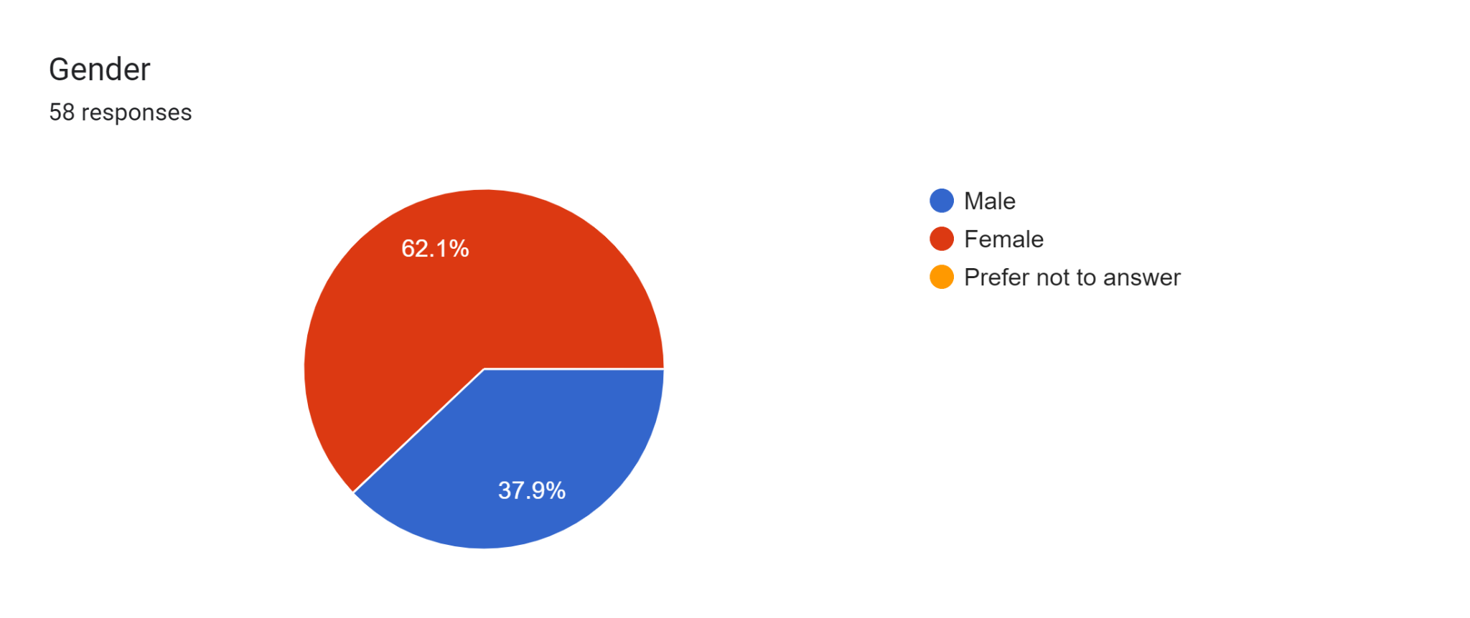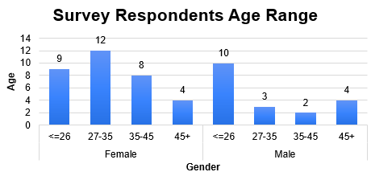

**Data collection and Implementation.**

The Smart Glasses survey commenced with an initial phase of in-person data collection, facilitated through Excel spreadsheets. Nine participants were selected and engaged in this preliminary stage to provide insights on various aspects of the Smart Glasses, including Product Features, Design Preferences, Comfort & Fit, Technology Integration, Brand Perception and Trust, Price Sensitivity, as well as Usage Scenarios. The data acquired during this phase served as the foundation for shaping the subsequent survey. After determining what attributes were important to the initial respondents, the survey transitioned to its final phase using Google Forms. The Google forms enabled the creation and dissemination of the survey via email and text messages. Through this iterative process, the survey methodology evolved to capture a wider audience feedback essential for the refinement and development and understanding of Smart Glasses and the market.

**key results of conjoint analysis**: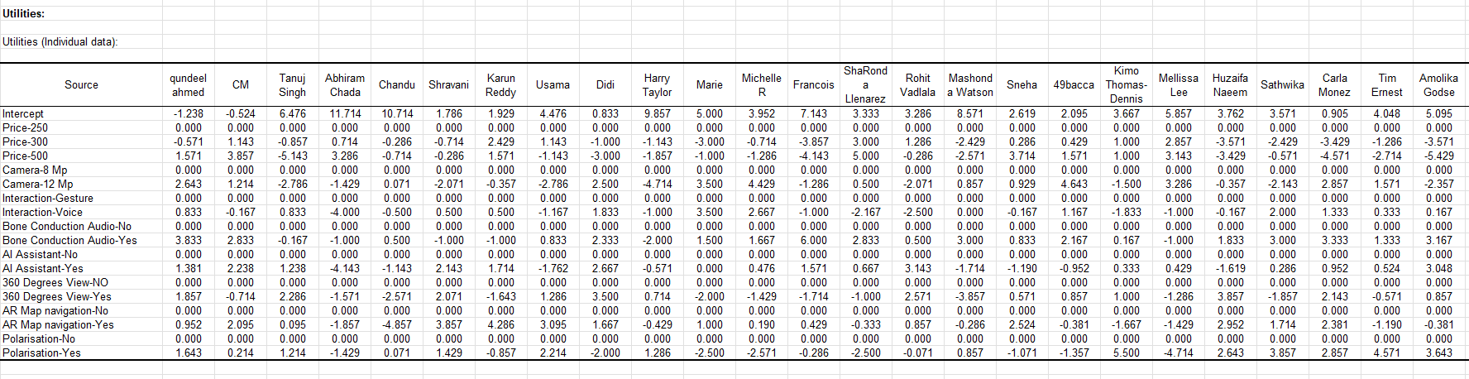

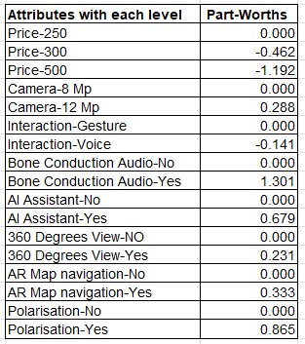

**Interpretation of Part-Worths**:

**Price**: The base level (Price-250) has a part-worth of 0, indicating it is the reference point. Price-300 has a negative utility (-0.462), which suggests it is less preferred than Price-250, and Price-500 is even less preferred, with a much lower utility of -1.192.

**Camera**: Camera-12 Mp is preferred over Camera-8 Mp (base level with a part-worth of 0) with a positive utility of 0.288.

**Interaction Methods**: Interaction-Gesture (part-worth of 0) is the reference, Interaction-Voice has a negative utility (-0.141), indicating it is less preferred when compared to Gesture control.

**Bone Conduction Audio**: The 'Yes' option is much more preferred with a utility of 1.301 compared to 'No' (base level). It is clear that people want Bone Conduction Audio

**AI Assistant**: Having an AI Assistant is preferred (part-worth of 0.679) over not having one (base level).

**360 Degrees View**: A 360 Degrees View is slightly preferred (part-worth of 0.231) over not having this feature.

**AR Map Navigation**: The 'Yes' option is preferred (part-worth of 0.333) over the 'No' option (base level).

**Polarisation**: Polarisation is significantly preferred with a utility of 0.865 compared to not having it (base level).

**Profile with Highest Utility**:

To find the profile with the highest utility, we choose the attribute levels with the highest part-worths (if the attribute is relevant, i.e., has a non-zero part-worth) and sum them:

Price-250: 0.000

Camera-12 Mp: 0.288

Bone Conduction Audio-Yes: 1.301

AI Assistant-Yes: 0.679

360 Degrees View-Yes: 0.231

AR Map Navigation-Yes: 0.333

Polarisation-Yes: 0.865

**Part-Worth with the Lowest Utility**:

This is the part-worth with the most negative value, which is for Price-500: -1.192.

**indicate the importance of the various attributes**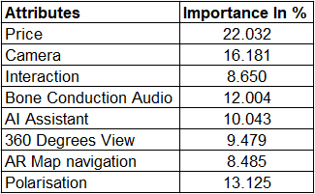

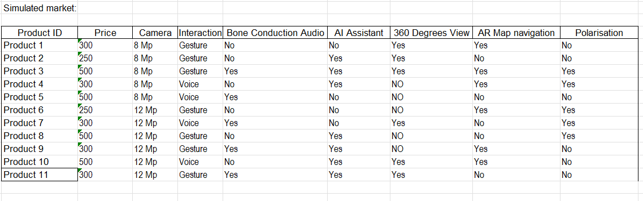

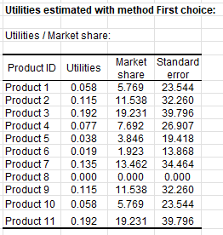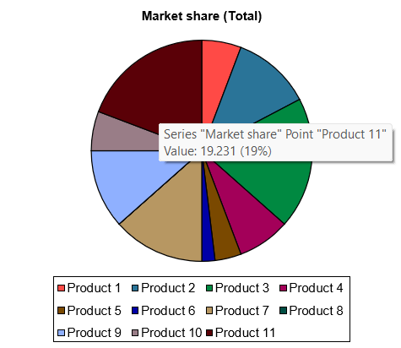

Profile 11, which was not initially selected, has been added to the simulated market to compete with the initially selected 10 profiles. After running the market simulation, Profile 11 has garnered a market share of approximately 19.231% (19%).

This is a substantial share, suggesting that despite not being originally selected, Profile 11 has a combination of attributes that are highly valued by the market. With a price point of $300, a 12 Mp camera, gesture interaction, bone conduction audio, an AI assistant, a 360-degree view, no AR map navigation, and no polarisation, this profile offers a mix of advanced and basic features that appeals to nearly a fifth of the simulated market.

**Utility Score**: Profile 11 has one of the higher utility scores among the profiles, indicating a strong preference for its specific combination of features.

**Balance of Features and Price**: The success of Profile 11 in the simulation suggests that the trade-offs between advanced features and cost are well-balanced, hitting a sweet spot in the market.

**Competitive Edge**: The market share of Profile 11 likely comes at the expense of other profiles with similar price points or feature sets, demonstrating the competitive nature of product feature combinations.

The simulated 19% market share places Profile 11 as a significant contender, especially if we consider that the market share is distributed among 11 different profiles. This suggests a strong market viability for Profile 11, and it could likely become a market leader with proper marketing and positioning strategies.